# C2- S6 - PRACTICE

*NOTE: check your* ***THEORY slides*** *to answer those questions!*

# EXERCISE 1 – DISCOVER ON DELETE CASCADE STATEMENT

We want to manage Student and Class:

* A student always has one class (Example: Lyhour is in WEP B)
* A class can have many students (Example: WEP A has all the second year girls)

**PART 1 – WITHOUT <ON DELETE CASCADE>**

**Q1** - What is the relation between Student and Class table?

The relation between Student and Class table one to many because

* Each student has got only one class.
* Each class has many students.

**Q2 -** Complete the missing field in the Student table.

The missing field in the Student table is ‘class_id’

**Q3 -** For each table, complete the following arrays, by specifying for each field:

* + The field type (SQL type) and size
  + Can be null or not?
  + Is a primary key or foreign keys?

**CLASS TABLE**

|  |  |  |  |
| --- | --- | --- | --- |
| Field | Type / size | Null? | Key |
| class_id | int(10) | no | PRI |
| name | Varchar(100) | no |  |

**STUDENT TABLE**

|  |  |  |  |
| --- | --- | --- | --- |
| Field | Type / size | Null? | Key |
| student_id | int(100) | no | PRI |
| first_name | Varchar(100) | no |  |
| last_name | Varchar(100) | no |  |
| class_id | Int(10) | no | MUL |

**Q4** - Write the SQL statement to create the 2 tables with appropriate properties

Class table

create table class (

    class_id int(10) auto_increment not null primary key,

    name varchar(100) not null

);

Student table

create table student (

    student_id int(10) auto_increment not null primary key,

    first_name varchar(100) not null,

    last_name varchar(100) not null,

    class_id int(10),

    foreign key (class_id) references class(class_id)

);

**Q5 –** Write the statement to insert the following classes and students

Notes:

* We don’t specify the KEY, it’s your business!

**CLASS**

|  |
| --- |
| Name |
| WEP A |
| WEP B |
| SNA |

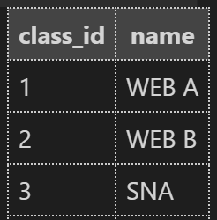

insert into class (name)

values ('WEB A'),

('WEB B'),

('SNA');

**STUDENT**

|  |  |  |
| --- | --- | --- |
| First Name | Last Name | His/her class |
| Lyhour | Ngorn | WEP B |
| Koem Sak | Mean | WEP B |
| Kunthy | Sen | WEP A |
| Channary | Pha | WEP A |
| Chanthy | Tha | WEP B |

insert into student (first_name,last_name,class_id)

values ('Lyhour','Ngorn',2)

         ('Koem Sak ','Mean',2),

         ('Kunthy','Sen',1),

         ('Chanary','Pha',1),

         ('Chanthy','Tha',2);

**Q6 –** Write the statement to delete the class WEP A

* What happens? Can we delete it? Why?

delete from class where name='WEB A';

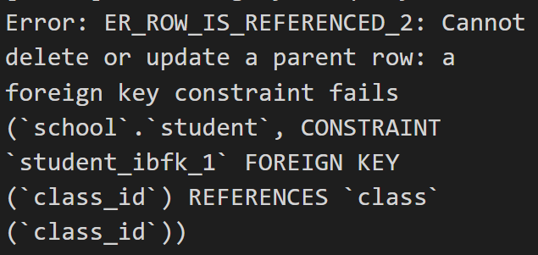

We cannot delete class WEB A because class table is parent table that student is a

child table has got rows that link with class table.

**PART 2 – WITH <ON DELETE CASCADE>**

**Q7 -** Write the statement to delete the table student

drop table student;

**Q8 –** Write the statement to create again the table student, but this time, you need to add ON DELETE CASCADE next to the line where you reference the foreign key class_id.

Like in this example:

------------------------------------------------------------------------

CREATE TABLE hard_candy

(candy_num INT,

candy_flavor CHAR(20),

FOREIGN KEY (candy_num) REFERENCES all_candy ON DELETE CASCADE);

------------------------------------------------------------------------

create table student (

    student_id int(10) auto_increment not null primary key,

    first_name varchar(100) not null,

    last_name varchar(100) not null,

    class_id int(10),

    foreign key (class_id) references class(class_id) on delete cascade

);

**Q9 -** Write the statement to insert again the following students in the student table (same statement as Q5).

**STUDENT**

|  |  |  |
| --- | --- | --- |
| First Name | Last Name | His/her class |
| Lyhour | Ngorn | WEP B |
| Koem Sak | Mean | WEP B |
| Kunthy | Sen | WEP A |
| Channary | Pha | WEP A |
| Chanthy | Tha | WEP B |

insert into student (first_name,last_name,class_id)

values ('Lyhour','Ngorn',2)

         ('Koem Sak ','Mean',2),

         ('Kunthy','Sen',1),

         ('Chanary','Pha',1),

         ('Chanthy','Tha',2);

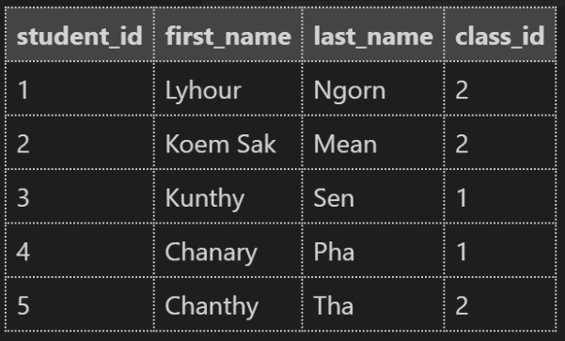

**Q10 -** Write the statement to delete the class WEP A

* What happens? Can we delete it?

Now we can delete it successfully. No error anymore.

**Q11 -** Write the statement to show the data that is in the student table. Try to understand why some students don’t appear anymore.

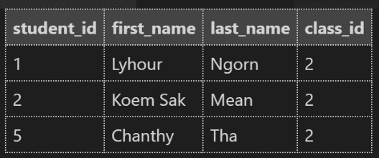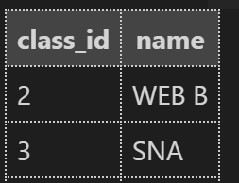

After we use ON DELETE CASCADE clause in MySQL is used to automatically **remove** the matching records from the child table when we delete the rows from the parent table. It is a kind of referential action related to the **foreign key**.

# EXERCISE 2 – INTRODUCTION TO BOOLEAN DATA TYPE

In the following questions, you need to choose between the suggested answers which data type is the right one to use for the attribute. You need to use this webpage:

<https://www.w3schools.com/mysql/mysql_datatypes.asp>

and explain your answer each time.

**Q1 –** What is the best data type to use for the attribute **first name** of the entity **Student**

1. CHAR(50)
2. VARCHAR(50)
3. BOOLEAN
4. VARCHAR(3)

**Q2 -** What is the best data type to use for the attribute **completed** of the entity **Task**

1. VARCHAR(3)
2. INT(1)
3. BOOLEAN
4. BOOL

**Q3 –** What is the best data type to use for the attribute **duration** of the entity **Movie**

1. DATE
2. TIME
3. INT(3)
4. TIMESTAMP

**Q4 –** What is the best data type to use for the attribute **activated** of the entity **Traffic light**

1. INT(1)
2. BOOLEAN
3. CHAR(3)
4. BOOL

**Q5 –** What is the best data type to use for the attribute **passed** of the entity **Exam**

1. TIME
2. VARCHAR(5)
3. BOOLEAN
4. STRING

**Q6 –** What is the best data type to use for the attribute **date of birth** of the entity **Student**

1. TIME
2. DATE
3. DATETIME
4. INT(100)

# EXERCISE 3 – NEED TO UPDATE DATA OF AN EXISTING TABLE

|  |  |  |  |  |  |  |  |  |  |  |  |  |  |  |  |  |  |  |  |  |  |  |  |  |  |  |  |  |  |  |  |  |  |  |  |  |  |  |  |  |  |  |  |  |  |  |  |  |  |  |  |  |  |  |  |  |  |  |  |  |  |
| --- | --- | --- | --- | --- | --- | --- | --- | --- | --- | --- | --- | --- | --- | --- | --- | --- | --- | --- | --- | --- | --- | --- | --- | --- | --- | --- | --- | --- | --- | --- | --- | --- | --- | --- | --- | --- | --- | --- | --- | --- | --- | --- | --- | --- | --- | --- | --- | --- | --- | --- | --- | --- | --- | --- | --- | --- | --- | --- | --- | --- | --- |
| **CUSTOMER** | | | | | | | | | | | | | | | | | | | | | | | | | | | | | | | | | | | | | | | | | | | | | | | | | | | | | | | | | | | | | |
| **Name** | **Type** | **Description** |  |  |  |  |  |  |  |  |  |  |  |  |  |  |  |  |  |  |  |  |  |  |  |  |  |  |  |  |  |  |  |  |  |  |  |  |  |  |  |  |  |  |  |  |  |  |  |  |  |  |  |  |  |  |  |  |  |  |  |
| ID | INT(100) | A customer ID in the inclusive range *[1, 1000]*. This is the primary key. |  |  |  |  |  |  |  |  |  |  |  |  |  |  |  |  |  |  |  |  |  |  |  |  |  |  |  |  |  |  |  |  |  |  |  |  |  |  |  |  |  |  |  |  |  |  |  |  |  |  |  |  |  |  |  |  |  |  |  |
| NAME | VARCHAR(2) | A customer name. This field contains between *1* and *100* characters (inclusive). |  |  |  |  |  |  |  |  |  |  |  |  |  |  |  |  |  |  |  |  |  |  |  |  |  |  |  |  |  |  |  |  |  |  |  |  |  |  |  |  |  |  |  |  |  |  |  |  |  |  |  |  |  |  |  |  |  |  |  |
| COUNTRY | CHAR(10) | The country of the customer. |  |  |  |  |  |  |  |  |  |  |  |  |  |  |  |  |  |  |  |  |  |  |  |  |  |  |  |  |  |  |  |  |  |  |  |  |  |  |  |  |  |  |  |  |  |  |  |  |  |  |  |  |  |  |  |  |  |  |  |
| CREDITS | INT(1000) | The credit limit of the customer. |  |  |  |  |  |  |  |  |  |  |  |  |  |  |  |  |  |  |  |  |  |  |  |  |  |  |  |  |  |  |  |  |  |  |  |  |  |  |  |  |  |  |  |  |  |  |  |  |  |  |  |  |  |  |  |  |  |  |  |
| ACCOUNT ACTIVATED | BOOLEAN | Tells if the customer’s account is activated or not |  |  |  |  |  |  |  |  |  |  |  |  |  |  |  |  |  |  |  |  |  |  |  |  |  |  |  |  |  |  |  |  |  |  |  |  |  |  |  |  |  |  |  |  |  |  |  |  |  |  |  |  |  |  |  |  |  |  |  |

**Q1 –** Write the statement to create the **Customer** table with the appropriate properties

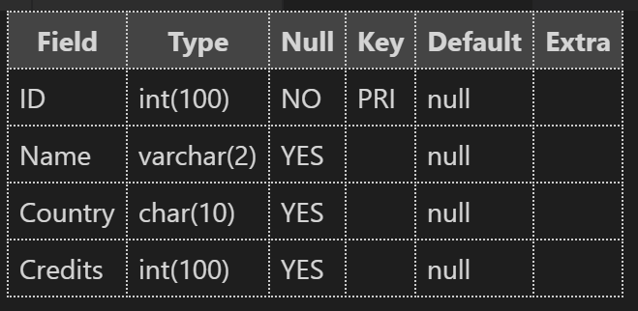 create table customer (

     ID int(100) primary key,

     Name varchar(2),

     Country char(10),

     Credits int(100)

);

**Q2 –** Write the statement to modify the type of the column **Country** from CHAR(10) to VARCHAR (20)

alter table customer modify Country varchar(20);

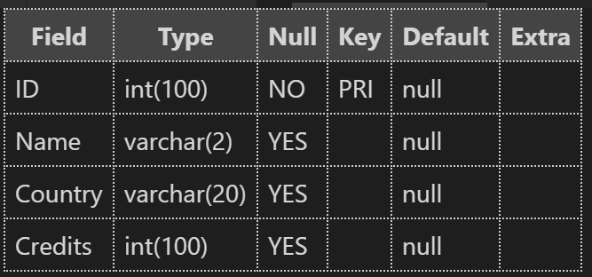

**Q3 –** Write the statement to modify the name of thecolumn **Name** to **First Name**

alter table customer change Name First_name;

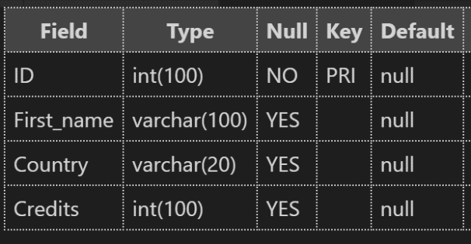

**Q4 –** Write the statement to modify the type of the column **First Name** from VARCHAR(2) to VARCHAR(50).

alter table customer modify First_name varchar(50);

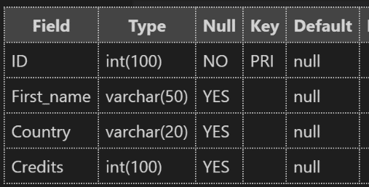

**Q5 –** Write a statement to add a new column to the table **Customer,** called **Last Name**

alter table customer add Last_name varchar(100);

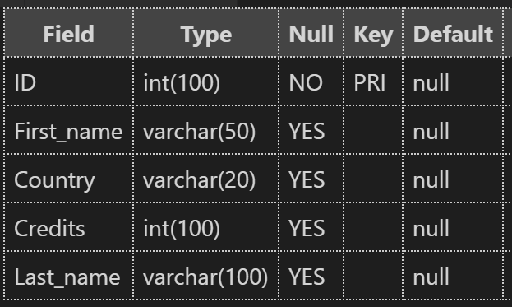

**Q6 –** Write a statement to insert all the following data in the table **Customer**

First Name – Last Name – Country – Credits – Account activated

-----------------------------------------------------------------------

Diane Reynolds UK 9260714 FALSE

Larry Burke USA 7414650 FALSE

Dennis Reid Singapore 2721484 FALSE

Joe Cruz Canada 7776372 FALSE

Robin Shaw Albania 4793116 FALSE

Donald Morrison China 1384666 FALSE

Eugene Hall UK 8910281 FALSE

Donald Gilbert Albania 6669850 FALSE

Samuel Harvey USA 5719094 FALSE

Robin Scott Singapore 6929083 FALSE

insert  into customer(ID,First_name,Last_name,Country,Credits,account_activated)

values (1,'Diane','Reynolds','UK',9260714,false),

       (2,'Larry','Burke','USA',7414650,false),

       (3,'Dennis','Reid','Singapore',2721484,false),

       (4,'Joe','Cruz','Canada',7776372,false),

       (5,'Robin','Shaw','Albania',4793116,false),

       (6,'Donald','Morrison','China',1384666,false),

       (7,'Eugene','Hall','UK',8910281,false),

       (8,'Donald','Gilbert','Albania',6669850,false),

       (9,'Samuel','Harvey','USA',5719094,false),

       (10,'Robin','Scott','Singapore',6929083,false);

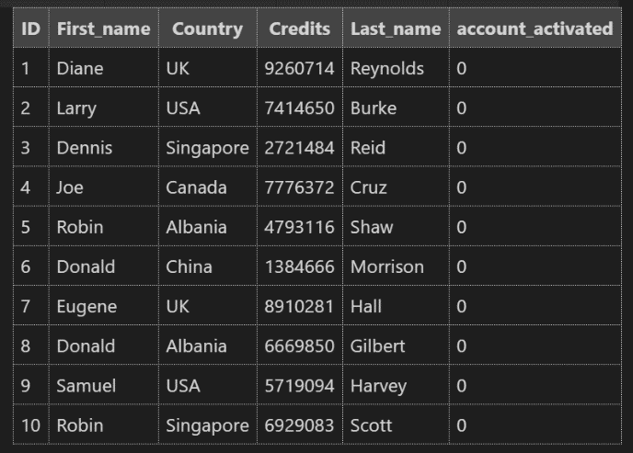

**Q7 –** All the customers from the USA now have their account activated: **write a statement to modify the data of the right records to take it into account.**

update customer set account_activated = true where Country='USA';

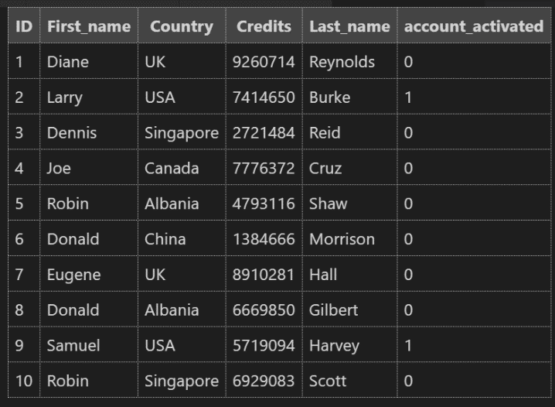

**Q8 –** Diane got married with Samuel so here last name changed from Reynolds to Harvey-Reynolds. **Write a statement to update the data in the right record.**

update customer set Last_name = 'Harvey-Reynolds' where First_name = 'Diane';

update customer set Last_name = 'Harvey-Reynolds' where First_name = 'Samuel ';

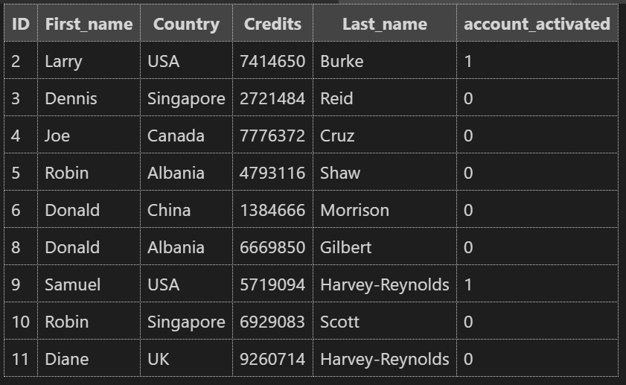

**Q9 –** The company does not work in the UK anymore so they don’t need the data of their former UK customers. **Write a statement to delete the records of the UK customers.**

delete from customer where Country = 'UK';

